**Topic**: Vigour Mingle (VM) Fitness Website

**EQ**: How can we develop a free website for the people who want to maintain a healthy lifestyle?

**Colour scheme**: #26305a, #ffffff, #35437e, #171d36, #e6e6e6

**Wireframe** (home page):

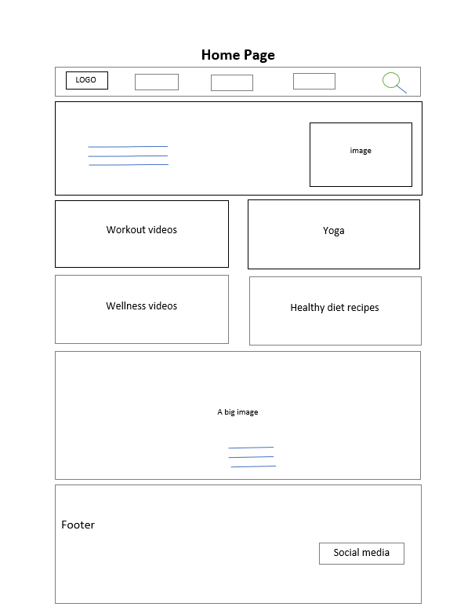

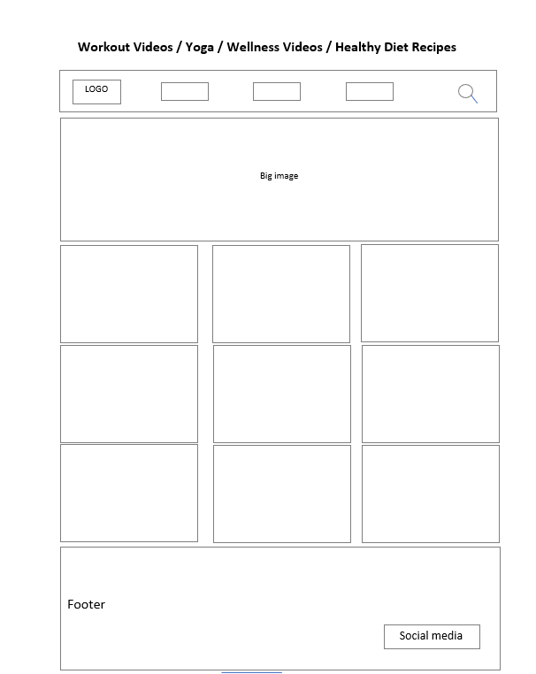

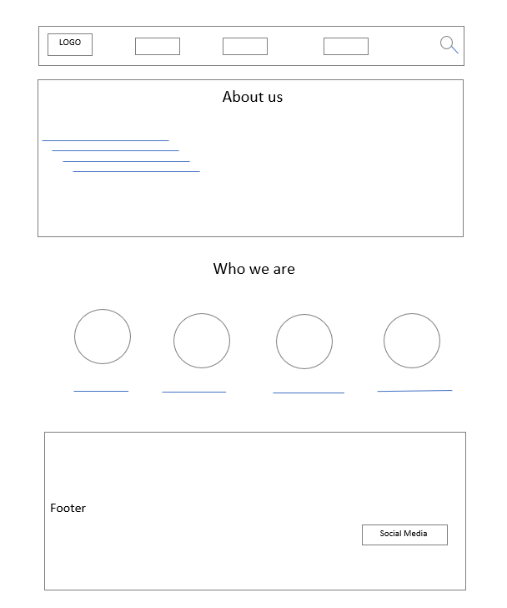

***Citation***

Workout videos

boys

<https://youtu.be/oAPCPjnU1wA>

<https://youtu.be/_W9B2ffnO5c>

<https://youtu.be/xngUfoWLkFw>

<https://youtu.be/XNgP5HsjcbE>

<https://youtu.be/JIQUbPqfVV4>

girls

<https://youtu.be/cIuiQyfKBTg>

<https://youtu.be/UBMk30rjy0o>

<https://youtu.be/aCa8R9II8F0>

<https://youtu.be/vaq7YpCwH7M>

<https://youtu.be/0XBcrjkkwQo>

Yoga videos

<https://youtu.be/VaoV1PrYft4>

<https://youtu.be/uiM9F-iJ7VQ>

<https://youtu.be/v7AYKMP6rOE>

<https://youtu.be/ehUQNsyTKCc>

<https://youtu.be/kFhG-ZzLNN4>

<https://youtu.be/g_tea8ZNk5A>

<https://youtu.be/8TuRYV71Rgo>

<https://youtu.be/COp7BR_Dvps>

<https://youtu.be/kQ10v41oglM>

Wellness videos

<https://youtu.be/4pLUleLdwY4>

<https://youtu.be/4ju2G3KtKNA>

<https://youtu.be/NQcYZplTXnQ>

<https://youtu.be/N-XStf-faqQ>

<https://youtu.be/6Y5VWBLi1es>

<https://youtu.be/wnHW6o8WMas>

<https://youtu.be/tbnzAVRZ9Xc>

<https://youtu.be/bP9gMpl1gyQ>

<https://www.youtube.com/live/u5EWe5baBck?feature=share>

Healthy recipe

<https://pin.it/1qAqYLN>

<https://pin.it/1im6kkw>

<https://pin.it/3FG4Hk1>

<https://www.homemademastery.com/healthy-ice-cream-no-machine/>

<https://www.bbcgoodfood.com/recipes/collection/healthy-dinner-recipes-to-lose-weight>

Logo

[Free Logo Maker - Get Custom Logo Designs in Minutes | Looka](https://looka.com/editor/113175391)

Banner

<https://www.freepik.com/>

<https://www.vogue.in>

<https://www.freepik.com/>

<https://unsplash.com>